**Graphs**

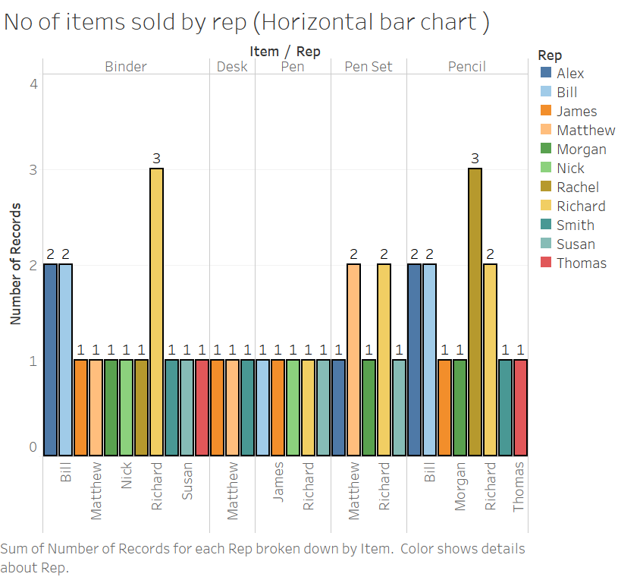

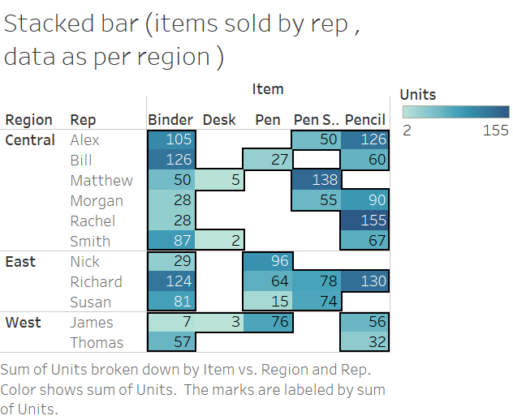

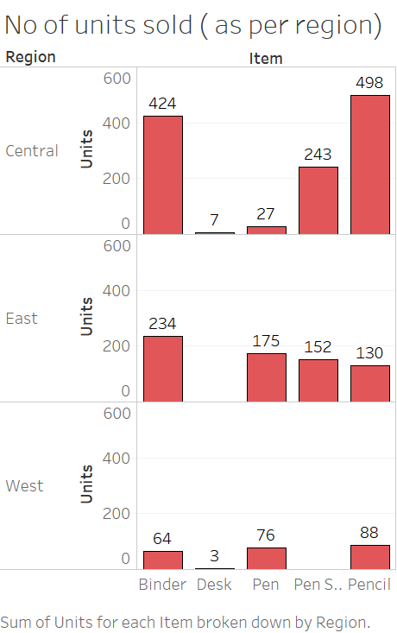

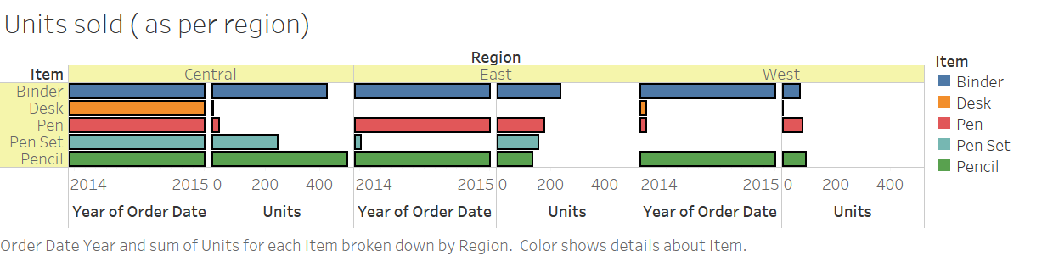

**Adding Currency**

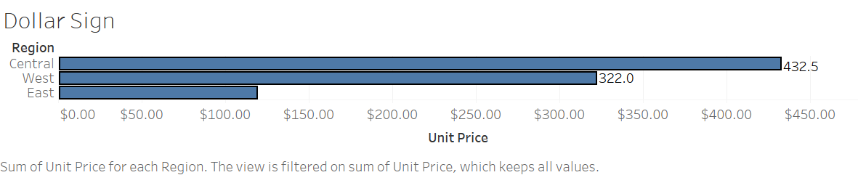

Live & Extract connection

Tableau Data Extracts are snapshots of data optimized for aggregation and loaded into system memory to be quickly recalled for visualization. Extracts tend to be much faster than live connections, especially in more complex visualizations with large data sets, filters, calculations, etc. When you create an extract from a local file (such as a .csv or an Excel workbook) or an on-premise database, you’re speeding up the workbook through optimization. As a result, Tableau doesn’t need the database to build the visualization. Instead, Tableau’s in-memory data engine queries the extract directly. However, because an extract is a snapshot of the data, the extract will need to be refreshed to receive updates from the original data source, whether it is a local file or an on-premise database.

Live connections offer the convenience of real-time updates, with any changes in the data source reflected in Tableau. But live connections also rely on the database for all queries. And unlike extracts, databases are not always optimized for fast performance. With live connections, your data queries are only as fast as the database itself.There are also more variables at play when using a live connection. Workbook speeds are affected by a variety of factors, including your network speed, traffic on that network, and any custom SQL.

An extract or a live connection—which to use?

Both types of connections have their place. Hospitals that monitor incoming patient data need to make real-time decisions. These situations necessitate a live database connection. But in the same hospital, there may also be visualizations that monitor daily or weekly trends. For these analytics, using an extract of the data source helps build a faster workbook.

Overlapping of data / labels in graph

Click on the Label icon, at the bottom of the menu uncheck "Allow labels to overlap other marks".  You can also manually select and move the overlapping labels right on the chart.